Dhruv Sandesara and Sean Tremblay: Lab 9 Deliverables

**Deliverables (exact components of the lab report)**

1. Objectives (1/2 page maximum)

The objective of this lab is to:

• Study ADC conversion and the Nyquist Theorem

• and develop a temperature measurement system using a thermistor,

B) Hardware Design

Circuit diagram of the thermistor interface

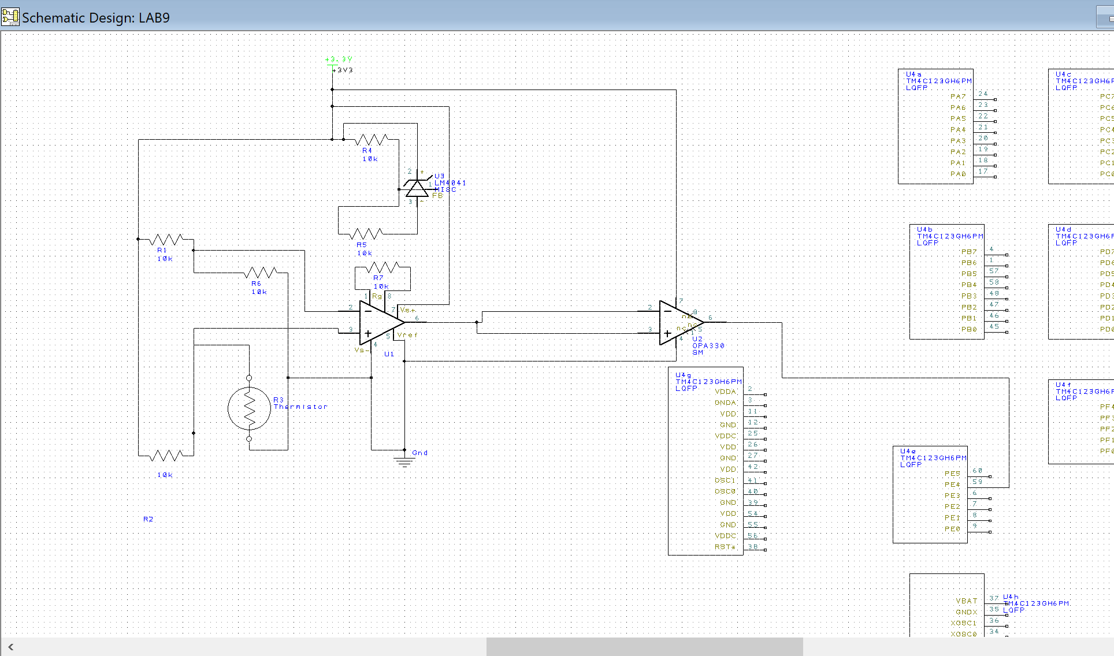

C) Software Design (a hardcopy software printout is due at the time of demonstration)

1) **Calibration data (procedure 5** and the **calib.h** file)

Attatched with the deliverables. Not in calib.h but calib.c file

2) Low level ADC interface (**ADC.c** and **ADC.h** files)

Attatched with the deliverables

3) Main program used to measure temperature

Attatched with the deliverables

D) Measurement Data

1) Sketch three waveforms (procedure 1)

2) Static circuit performance (procedure 2)

Thermisotor shorted: Value of temperature is 37 degrees which is outside our supported temp range

Thermisor removed : Values of temperature is 23.1 degrees which is also outside our supported range

**3) Dynamic circuit performance (procedure 3)**

**4) Accuracy (procedure 6)**

**Data:**

**26.96**

**27.02**

**26.98**

**26.84**

**27.01**

**26.87**

**26.93**

**26.99**

**27.02**

**26.98**

**Average is: 26.96**

**Room temperature is 25 degrees or 77 ferhernite**

**Thus accuracy is 1.96 degrees.**

**Mostly the error lies with the calibration tables as they stay roughly 2 degrees off.**

**5) Reproducibility (procedure 7)**

|  |  |
| --- | --- |
| Data: |  |
| 2846 |  |
| 2841 |  |
| 2844 |  |
| 2845 |  |
| 2844 |  |
| 2846 |  |
| 2844 |  |
| 2842 |  |
| 2840 |  |
| 2840 |  |
|  |  |

|  |  |
| --- | --- |
| Population Standard Deviation, σ | 2.1817424229271 |
| Variance (Population Standard), σ2 | 4.76 |
| Total Numbers, N | 10 |
| Sum: | 28432 |
| Mean (Average): | 2843.2 |
| Standard Error of the Mean (SEx̄): | 0.72724747430905 |

**Therefore reproducabality is 99.3 ish%**

E) Analysis and Discussion (give short answers to these questions)

1) What is the Nyquist theorem and how does it apply to this lab?

The Nyquist theorem says that to recover any frequency from a wave, the wave should be sampled at a rate at least twice the max frequency. Otherwise, the frequency is aliased and not recoverable from the wave. It applies to our lab as we expect the fastest the temperature to change is 50 hz, which is why we are sampling at a rate of 100Hz

2) Explain the difference between resolution and accuracy?

Resolution is the smallest difference in temperature change that we can measure. This depends on mostly tiniest difference in voltage our ADC can measure and that multiplied by how much we are scaling our ADC measurements to temperature values. Accuracy instead depends on how close to the actual temperature our reading is.

3) Derive an equation to relate reproducibility and precision of the thermometer.

Well the reproducibility of our experiment must be 100% as the only environmental variable is the temperature and if the whole equipment is measured at the same temperature it should give the same values. Otherwise just looking at the adc values we can calculate the jitter by just looking at the standard deviation of the measured temperature data for a const temp like room temperature. The precision of our ADC converter is 12 bits or 4096 alternatives. Thus we can find at most 4096 different thermometer values. Which for our range of 25 to 35 defrees gives resolution of 10/4096 or 0.002 celcius

4) What is the purpose of the LPF?

The purpose of the LPF is to filter out high frequencies that can cause aliasing in our measured readings. These mostly include the power frequency at 60 hz and their harmonics.

5) If the R versus T curve of the thermistor is so nonlinear, why does the voltage versus temperature curve look so linear?

This is as the bridge that we use takes into account the temperature constrains that we will be operating the thermistor in and gives us the 3 resistor values to use with it. This change in resitance will trigger a change in voltage that will be amplified by the amplification opamp and thus we will get a nice linear line for the V vs T graph.

6) There are four methods (a,b,c,d) listed in the **4) Software Conversion** section of methods and constraints. For one of the methods you did not implement, give reasons why your method is better, and give reasons why this alternative method would have been better.

One method that we could have used was continuous sampling. This method would have been better as the number of frequencies and the quick changes in temperature that it would have been able to pick up would have been much greater as it would be continuously sampling at a very high frequency. I still believe that our method of timer triggered ADC sampling is better as it uses a lot less power compared to continuous sampling. Also we never anticipated the temperature to change much faster than 10-50Hz thus our sampling rate was enough and we never needed the continuous sampling.